PAPER EVALUATION USING ARTIFICIAL INTELLIGENCE (HYBRID AI FRAMEWORK FOR RESEARCH PAPER EVALUATION AND REVIEWER RECOMMENDATION)
Design and Implementation
Department of Computer Science and Engineering, TKR College of Engineering & Technology
Batch C8 (CSE-C) · Academic year [ACADEMIC YEAR]
Table 1: Project team
S.No. | Student name | Roll number
1 | Mula Sreebindu | 23K91A05G3
2 | Puramshetty Vishnu Vardhan | 23K91A05K2
3 | K Sampoorna | 24K95A0512
4 | Korsa Shivashankar | 24K95A0515

Project guide: M Anupama
Chapter and section numbers quoted in the text (for example Chapter 8 or Section 6.2) refer to the full project report, 17.Final Document. Figures and tables in this document are numbered from 1.

1. DESIGN
This chapter turns the requirements of Chapter 4 into a design. It gives the architecture, the workflow of one analysis, the data flow diagrams, the UML models, the database, the module design, the interface design and the reasons for the main design decisions. Every diagram was drawn from the code in the repository (app/, scripts/ and frontend/), not from a plan, and each is listed again with a short explanation in the block-diagram document.

1.1 Design Goals and Architecture
Four goals shaped the design. The first is local-first operation: a paper should never leave the machine except as a short query. The second is graceful degradation: the system should always return something useful, even when the language model, the embedding model or the internet is unavailable, and it must say which part is missing instead of inventing it. The third is auditability: every number in a reviewer ranking should be explainable from values that are stored with the result, which is the principle of the base paper [1]. The fourth is simplicity of operation: one launcher, one configuration file, one database file.
The architecture has four tiers over a set of local stores. The presentation tier is a React single-page application served by the Vite development server on port 5408. It has eight pages and a thin client module, lib/api.js, which calls the API through fetch and turns every failure into a message that is safe to show. The application tier is a FastAPI service on port 8408 whose routes are all defined in app/main.py. It validates input, opens a database session per request, calls the service tier and converts errors into JSON responses. The service tier, app/services, holds the working modules. A single function, pipeline.run_analysis, orchestrates them for one paper. The data tier is SQLite for the reviewer directory and the stored analyses, the decision-model files, the training CSV, and the Hugging Face cache that holds the language-model weights.
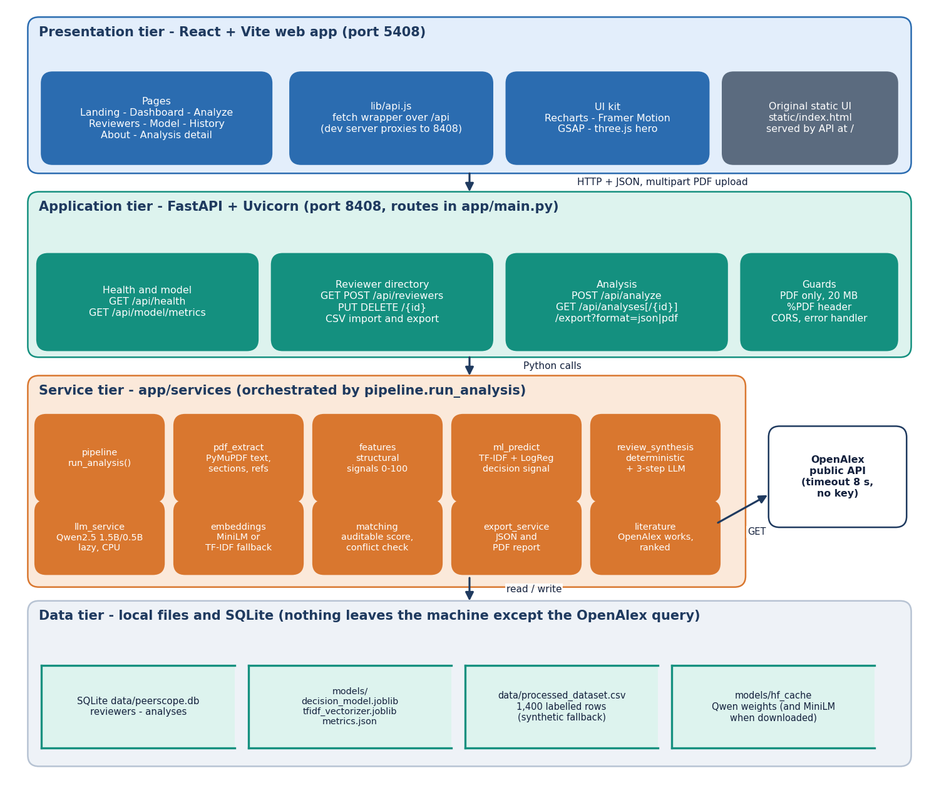
Figure 1: Four-tier architecture of PeerScope: React web app, FastAPI application, Python services and local data stores.
One external system is used: the OpenAlex public API, which receives a title or keyword query and returns related works. The service tier is written as plain Python modules of functions, not as a class hierarchy. That is a deliberate choice: each stage takes a dictionary and returns a dictionary, so it can be tested on its own, replaced without touching the others, and the whole result can be stored as JSON. The UML class diagram in Section 5.4 draws these modules as classes only to show their responsibilities. A static page in static/ from the first version of the interface is still served at the root of the API as a fallback.
Table 2: Tiers, technologies and responsibilities
Tier | Technology | Responsibility
Presentation | React, React Router, Vite, Recharts, Framer Motion, GSAP, three.js | Eight pages, forms, tables, charts, theme, error and loading states
Application | FastAPI, Uvicorn, Pydantic, SQLAlchemy | Routes, input validation, upload guards, database sessions, error handler, CORS
Service | PyMuPDF, scikit-learn, sentence-transformers, Transformers, requests, ReportLab | Extraction, features, decision signal, review, literature, embeddings, matching, export
Data | SQLite, joblib, CSV, JSON, Hugging Face cache | Reviewers, analyses, model artefacts, training data, metrics, model weights

1.2 High-Level Workflow
The workflow of the system is the workflow of one POST /api/analyze request. It has ten stages. The upload is validated; the PDF text, title, sections and references are extracted; structural features are computed; the trained classifier gives a decision signal; a review is drafted, by the local language model when it loads and by deterministic rules otherwise; related literature is requested from OpenAlex; the reviewers in the directory are scored; the filters are applied and the best five are kept; and the whole result is stored and returned. The interface then shows the result in five tabs: Overview, Review, Literature, Reviewers, and Audit and export.
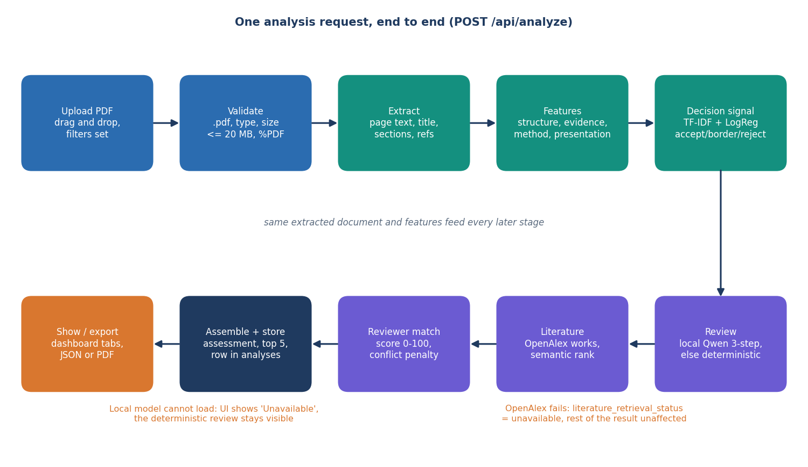
Figure 2: High-level workflow of PeerScope for one POST /api/analyze request.
There are two degradation paths. If the language model cannot be loaded, the review carries llm_status 'unavailable' together with the loader's error message and the deterministic review is shown. If OpenAlex cannot be reached within eight seconds, the literature block carries literature_retrieval_status 'unavailable' and an empty list. In both cases the other stages are unaffected. A third, implicit path concerns the embedding model: if it cannot be loaded the matching falls back to TF-IDF vectors.
Offline, a separate workflow prepares the decision model: prepare_dataset.py writes the training CSV, and train_model.py splits it, fits the vectorisers and the classifier, evaluates it and saves the artefacts and metrics. That workflow runs once, from run.bat if the model files are missing, and is drawn below.
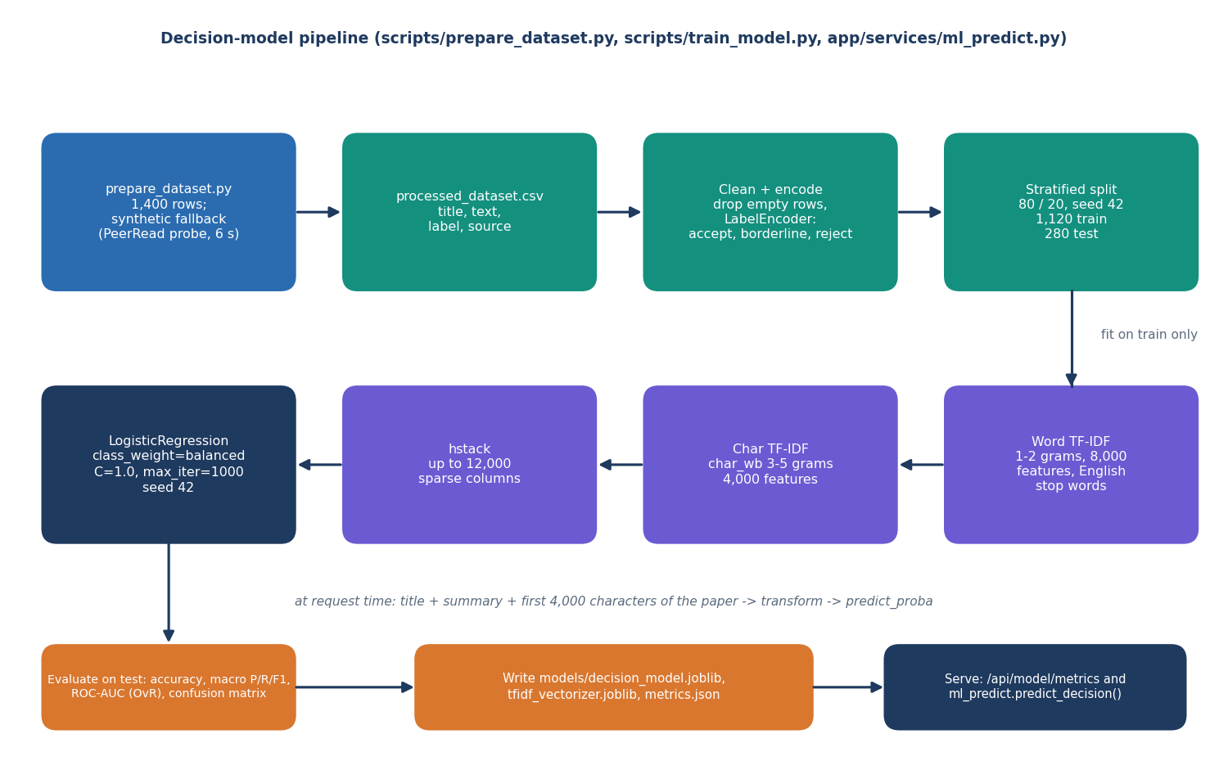
Figure 3: Training and serving pipeline of the decision model.
The PDF-reading stage deserves its own diagram because the later stages depend on it. Page text is extracted with PyMuPDF and normalised; the title is chosen by a heuristic; sections are found by matching short heading lines against nine patterns; the references are split after a References heading; and four structural signals are combined with fixed weights.
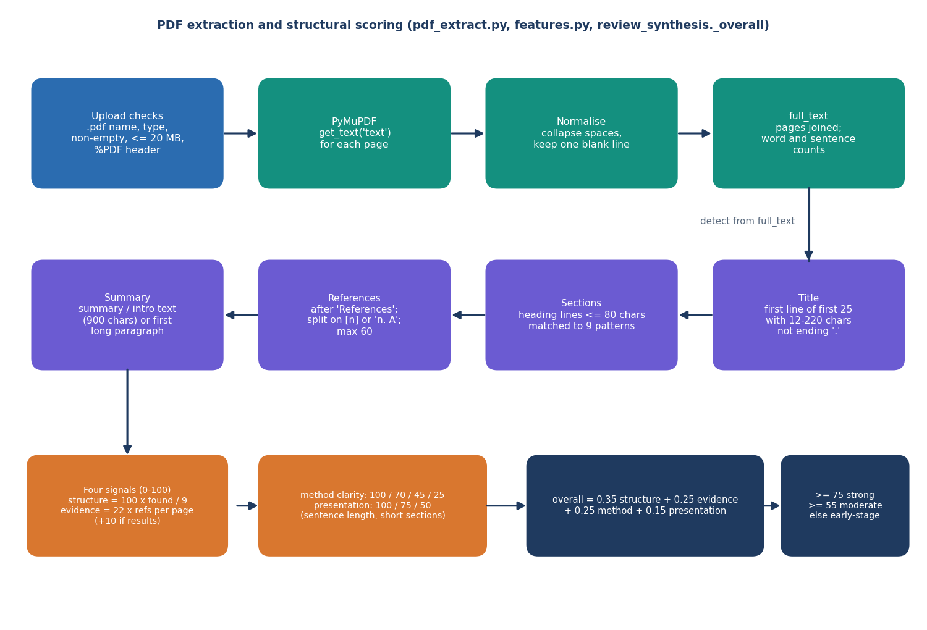
Figure 4: Flow of PDF extraction and structural scoring in PeerScope.

1.3 Data Flow Diagrams

1.3.1 Level 0: context
At the context level PeerScope is one process with three neighbours. The editor or programme chair sends a PDF and filter choices and receives the assessment, the ranked reviewers, the history and the exports. The reviewer-directory administrator sends profiles or a CSV file and receives the directory and its CSV export. OpenAlex receives a query and returns related works. The model metrics are read from local files and need no external actor.
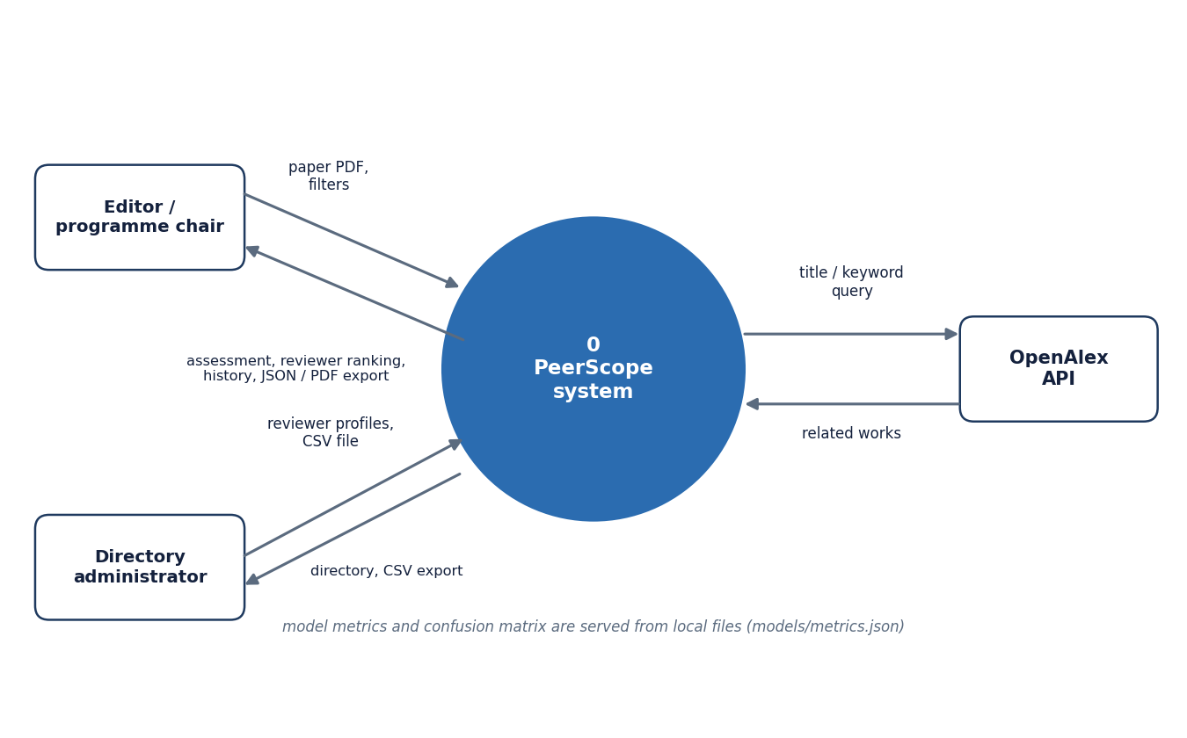
Figure 5: Context diagram (DFD level 0) of PeerScope with its two users and one external service.

1.3.2 Level 1: main processes
Level 1 divides the system into seven processes and three stores. The table gives the data that enter and leave each process.
Table 3: Level 1 processes and their data
No. | Process | Inputs | Outputs | Stores
1.0 | Validate and extract paper | PDF, filters | Text, sections, references, validation errors | -
2.0 | Assess paper | Text, sections, references; model files | Features, decision signal, review | D3 (read)
3.0 | Retrieve literature | Title, keywords, topics | Related works | OpenAlex (external)
4.0 | Match reviewers | Keywords, methods, topics, summary, reviewer profiles | Ranked reviewers with breakdown | D1 (read)
5.0 | Manage directory | Profiles, CSV file | Directory, CSV export, validation errors | D1 (read, write)
6.0 | Store, show and export | Assessment, literature, ranked reviewers | Result, history, JSON and PDF exports | D2 (read, write)
7.0 | Report model performance | Saved metrics | Metrics, confusion matrix, status | D3 (read)

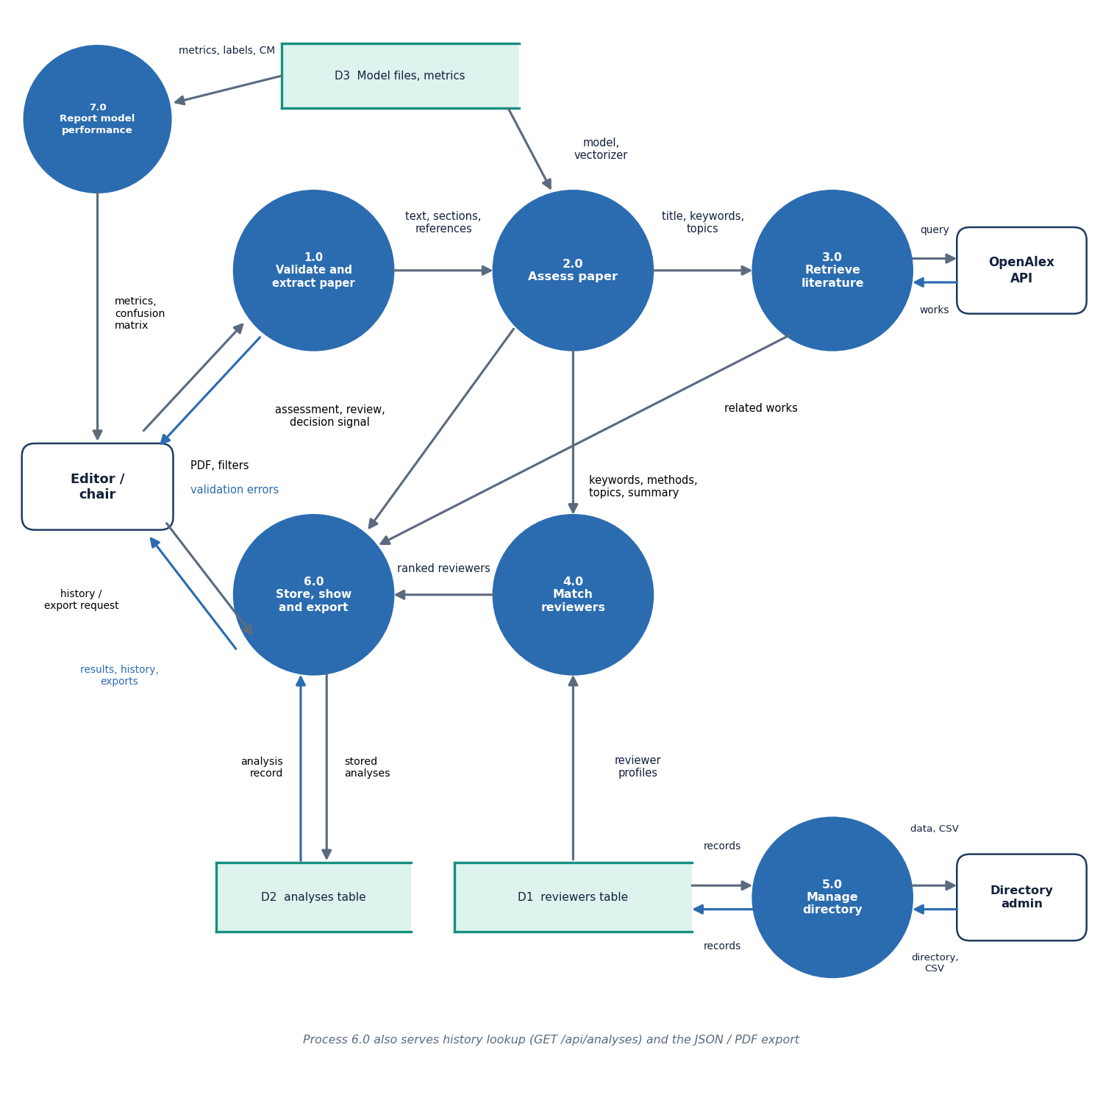
Figure 6: DFD level 1 of PeerScope: seven processes and three data stores.
The stores are D1, the reviewers table, D2, the analyses table, and D3, the model files with their metrics. Process 6.0 also serves the history lookup and the exports, which read D2.

1.3.3 Level 2: the analysis pipeline
Level 2 expands processes 1.0 to 4.0 into the steps of pipeline.run_analysis. Each step adds its output to one result dictionary, which is handed to process 6.0.
Table 4: Level 2 sub-processes
No. | Sub-process | Module and function | Data read
1.1 | Extract page text | pdf_extract.extract_pdf | Uploaded temporary PDF
1.2 | Detect title, sections, references | pdf_extract._detect_sections, _extract_references | Page text
2.1 | Structural features | features.extract_features | Document dictionary
2.2 | Decision signal | ml_predict.predict_decision | decision_model.joblib, tfidf_vectorizer.joblib
2.3 | Draft review | review_synthesis.llm_review | Qwen weights (optional)
3.1 | Retrieve literature | literature.retrieve_literature | OpenAlex works endpoint
4.1 | Profiles and embeddings | matching.paper_profile, reviewer_profile; embeddings.embed_texts | Reviewers table, MiniLM weights
4.2 | Score and rank reviewers | matching.match_reviewers | Profiles, embeddings, paper text

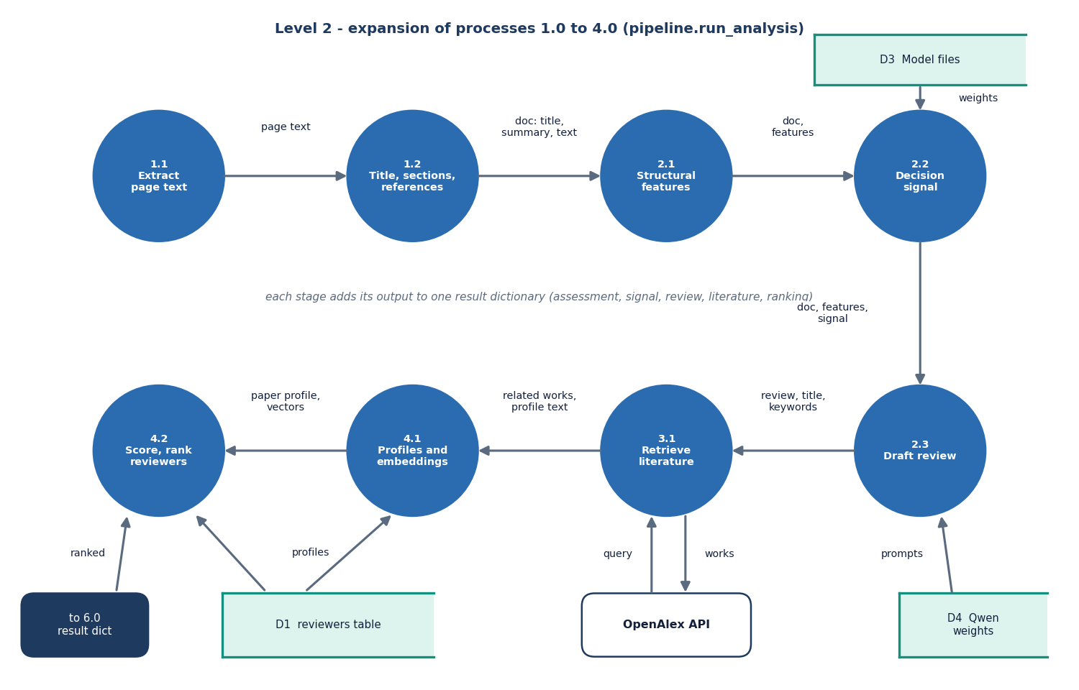
Figure 7: DFD level 2 of PeerScope: expansion of the analysis pipeline into eight sub-processes.

1.4 UML Diagrams

1.4.1 Class diagram
The class diagram below shows the classes of the system. Two are persistent: Reviewer and Analysis, the ORM classes that map to the two tables. ReviewerIn is the Pydantic schema that validates reviewer input and states its limits. The FastAPI application is drawn as a class with one method per route. Below it are the service modules, each with the functions it exposes: the Pipeline calls PdfExtractor, FeatureExtractor and MLPredictor, then ReviewSynthesis, LiteratureService and MatchingService; ReviewSynthesis optionally uses LLMService, and both LiteratureService and MatchingService depend on EmbeddingService. ExportService produces the JSON and PDF exports, and SeedData fills an empty directory at start-up. In the code these are modules of functions; the class notation is used to show what each owns.
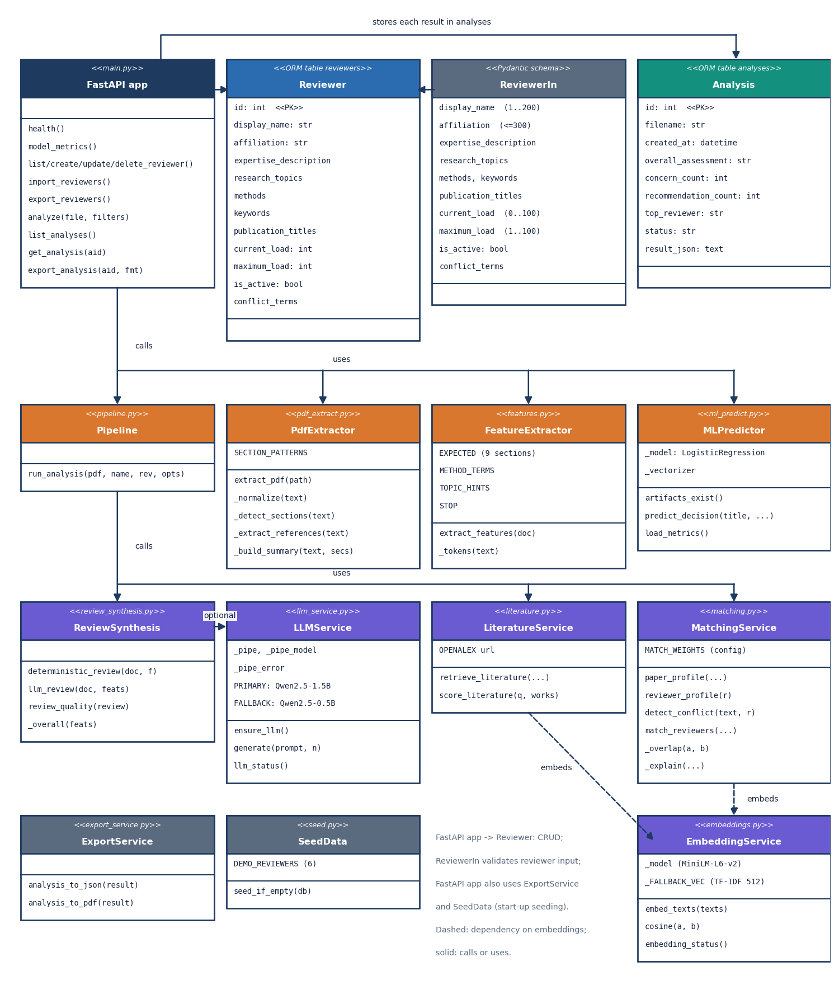
Figure 8: UML class diagram of PeerScope showing the ORM tables, the request schema, the FastAPI application and the service modules.

1.4.2 Sequence diagram
The sequence of an analysis has the browser at one end and the database at the other. The browser posts the PDF as multipart form data with the four filter fields. FastAPI checks the extension, the content type, the size and the %PDF header, writes a temporary file, loads the reviewer rows and calls run_analysis. The pipeline calls the extraction, feature, decision, review, literature and matching modules in that order, applies the filters, keeps five reviewers and returns the result dictionary. FastAPI inserts one row into the analyses table, deletes the temporary file in a finally block and returns the JSON with the new analysis identifier.
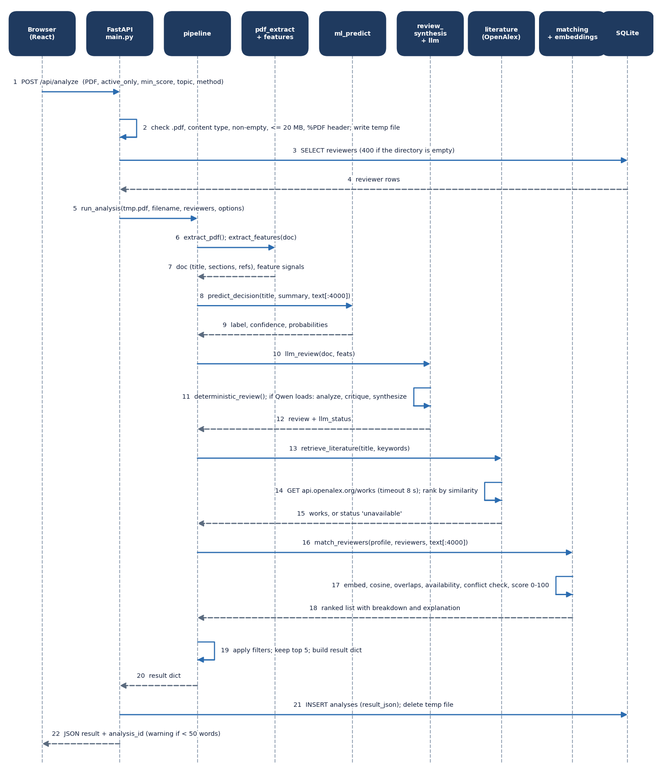
Figure 9: Sequence diagram of a paper analysis, from the browser upload to the stored JSON response.

1.4.3 Use-case diagram
The use cases follow the two human roles of Section 4.8. The editor or programme chair uploads a paper, reads the preliminary assessment and review, sees related literature, obtains ranked reviewers with an audit breakdown, exports the analysis, browses the history and views the model performance. Obtaining reviewers includes the conflict-of-interest check. The directory administrator manages reviewer records and imports or exports them as CSV. The local language model and OpenAlex appear as supporting systems.
Table 5: Principal use cases
Use case | Actor | Main flow | Alternative flow
Analyze a paper | Editor | Choose PDF, set filters, press Analyze, read the five tabs | Invalid file: message shown; backend offline: error state with retry
Obtain reviewers | Editor | Open the Reviewers tab, expand Audit details for a score breakdown | No reviewer passes the filters: empty state
Export an analysis | Editor | Open Audit and export or History, choose JSON or PDF | Unknown id: 404
Manage reviewers | Administrator | Add, edit, activate, deactivate or delete a profile | Validation error on the form
Import reviewers | Administrator | Choose a CSV with a display_name column | Malformed CSV: 400 and the database is rolled back
Check model performance | Editor | Open Model performance | Metrics file missing: status 'missing' message

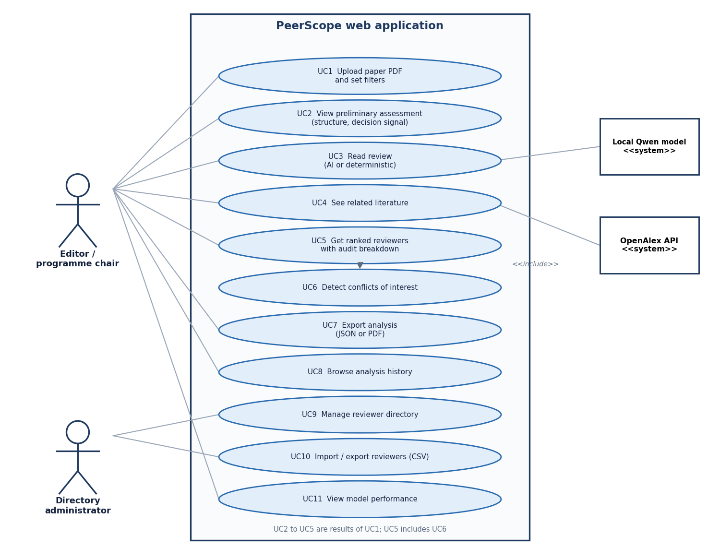
Figure 10: Use-case diagram of PeerScope with its two human actors and two supporting systems.

1.5 Database Design
PeerScope keeps two tables in a SQLite file, data/peerscope.db, created by SQLAlchemy's create_all when the API starts. SQLite was chosen because the system is single-user and local, needs no server and is backed up by copying one file. The check_same_thread restriction is disabled so that FastAPI's worker threads can share the engine, and a session is opened and closed for every request.
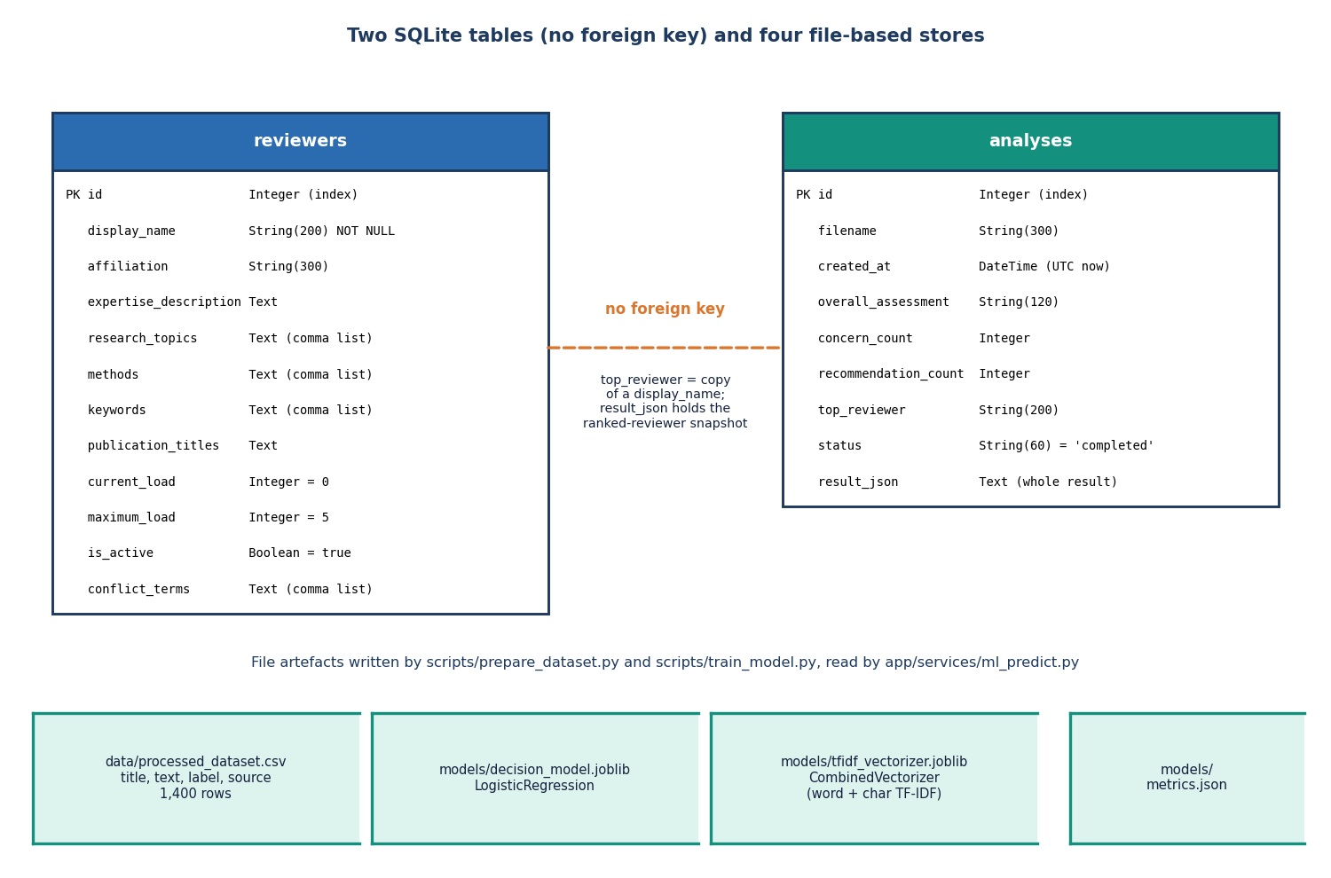
Figure 11: Entity-relationship diagram of the PeerScope SQLite tables and file-based stores.

1.5.1 The reviewers table
Table 6: Table reviewers
Column | Type | Default | Purpose
id | Integer, primary key, indexed | auto | Identifier
display_name | String(200), not null | - | Name shown and used in the conflict check
affiliation | String(300) | empty | Institution; conflict check
expertise_description | Text | empty | Free text embedded for semantic similarity
research_topics | Text (comma list) | empty | Topic overlap and filter
methods | Text (comma list) | empty | Method overlap and filter
keywords | Text (comma list) | empty | Keyword overlap
publication_titles | Text | empty | Embedded with the description
current_load | Integer | 0 | Papers now assigned
maximum_load | Integer | 5 | Most papers the reviewer accepts
is_active | Boolean | true | Whether the reviewer can be proposed
conflict_terms | Text (comma list) | empty | Strings that signal a conflict

Lists are stored as comma-separated text, not as a child table. The matching code splits them on commas, semicolons, bars and line breaks and lower-cases them, which keeps the CSV import and export a straight copy of the columns. The price of this choice is that the database cannot enforce the uniqueness of a term or query by term.

1.5.2 The analyses table
Table 7: Table analyses
Column | Type | Default | Purpose
id | Integer, primary key, indexed | auto | Analysis identifier used in URLs
filename | String(300) | empty | Name of the uploaded file
created_at | DateTime | UTC now | When the analysis was stored
overall_assessment | String(120) | empty | First 120 characters of the overall assessment, for the history list
concern_count | Integer | 0 | Major plus minor concerns
recommendation_count | Integer | 0 | Number of recommendations
top_reviewer | String(200) | empty | Name of the best-ranked reviewer at the time
status | String(60) | 'completed' | Status of the analysis
result_json | Text | '{}' | The complete result as JSON

There is no foreign key between the two tables. This is a design decision, not an omission: an analysis is a snapshot. Its result_json contains the five ranked reviewers as they were scored on that day, and top_reviewer is a copy of a name. If a reviewer is later edited or deleted, the stored analysis still shows what the editor saw, and the history never shows a broken reference. The price is that the history cannot be queried by reviewer through a join. The JSON document carries these top-level keys: product, filename, created_at, paper (title, summary, page, word and reference counts, sections, a four-page preview), features, ml_decision_signal, structural_assessment, review, review_quality, literature, reviewers, reviewer_pool_size, overall_assessment, concern_count, recommendation_count, top_reviewer, disclaimer and responsible_use, with analysis_id added after the insert.

1.5.3 File-based stores
Table 8: Files written and read by the system
File | Written by | Read by | Content
data/processed_dataset.csv | scripts/prepare_dataset.py | scripts/train_model.py | 1,400 labelled rows: title, text, label, source
models/decision_model.joblib | scripts/train_model.py | ml_predict | Class-balanced logistic regression
models/tfidf_vectorizer.joblib | scripts/train_model.py | ml_predict | CombinedVectorizer: word and character TF-IDF
models/metrics.json | scripts/train_model.py | GET /api/model/metrics | Metrics, confusion matrix, labels, dataset facts
models/hf_cache/ | Transformers on first load | llm_service | Qwen weights (embedding weights use the sentence-transformers cache)
data/demo/demo_paper.pdf | scripts/make_demo_pdf.py | tests, smoke test, screenshots | Three-page demo paper, clearly a fixture
data/tmp/ | tempfile | - | Temporary location for uploads; each file is deleted after its request

1.6 Module Design
The service tier has twelve modules, each with one responsibility. The table lists them with the functions they expose; names beginning with an underscore are internal.
Table 9: Modules of app/ and their public functions
Module | Responsibility | Functions
main.py | FastAPI app, routes, upload guards, error handler, start-up seeding | health, model_metrics, reviewer CRUD, import and export, analyze, list_analyses, get_analysis, export_analysis
config.py | Single source of tunable settings read from the environment and .env | paths, ports, upload limit, model names, literature settings, MATCH_WEIGHTS
database.py, models.py, schemas.py | SQLAlchemy engine and session, ORM classes, Pydantic validation | get_db, init_db, Reviewer, Analysis, ReviewerIn, HealthOut
services/pipeline.py | Orchestrates one analysis and applies filters | run_analysis
services/pdf_extract.py | Text, title, sections, references, summary | extract_pdf, _normalize, _detect_sections, _extract_references, _build_summary
services/features.py | Counts, keywords, lexicon hits and four structural signals | extract_features
services/ml_predict.py | Loads the decision model lazily and predicts | artifacts_exist, predict_decision, load_metrics
services/review_synthesis.py | Deterministic review and 3-step language-model review | deterministic_review, llm_review, review_quality
services/llm_service.py | Lazy, thread-safe loading of Qwen2.5 with a fallback model | ensure_llm, generate, llm_status
services/embeddings.py | MiniLM embeddings with a TF-IDF fallback | embed_texts, cosine, embedding_status
services/literature.py | OpenAlex retrieval and relevance ranking | retrieve_literature, score_literature
services/matching.py | Profiles, overlaps, conflict check, score and explanation | paper_profile, reviewer_profile, detect_conflict, match_reviewers
services/export_service.py | JSON and A4 PDF report of an analysis | analysis_to_json, analysis_to_pdf
services/seed.py | Six demo reviewers when the directory is empty | seed_if_empty
services/textvec.py | Importable CombinedVectorizer so that the saved vectoriser can be unpickled | CombinedVectorizer.transform

1.6.1 Extraction and features
pdf_extract.extract_pdf opens the file with PyMuPDF, takes the text of each page, collapses runs of spaces and blank lines, and joins the pages. The title is the first line among the first 25 that is between 12 and 220 characters long and does not end with a full stop. Section headings are short lines (at most 80 characters) that match one of nine pattern groups: summary, introduction, related work, methodology, experiments, results, discussion, conclusion and references. The text between one heading and the next becomes the section, with its word count and a 600-character preview. References are split after a References or Bibliography heading, or, failing that, taken from bracketed lines. The summary is the preview of the summary or introduction section, or the first long paragraph.
features.extract_features turns the document into numbers: pages, words, sentences, average sentence length, reference count and density per page, detected and missing sections, the share of very short sections, the fifteen most frequent non-stop-word tokens as keywords, hits from a 21-term method lexicon and an 18-term topic list, and four signals. Structure completeness is the share of the nine expected sections found. Evidence coverage is 22 times the reference density plus 10 if an experiments or results section exists, capped at 100. Method clarity is 100 for a methodology section of at least 120 words, 70 for a shorter one, 45 if only lexicon terms occur and 25 otherwise. Presentation is 100 for an average sentence length of 12 to 26 words with few short sections, 75 for 8 to 32 words and 50 otherwise. The overall structural score is 0.35, 0.25, 0.25 and 0.15 of these signals.
These weights and thresholds are heuristics chosen by the team. They were not fitted to human judgements, and Chapter 8 shows how they behave on four real papers, including two where the section detection fails.

1.6.2 Decision signal and review
ml_predict builds one string from the title, the summary and the first 4,000 characters of the text, transforms it with the saved vectoriser and returns the class probabilities of the saved model, the most probable label and its confidence, together with a note that the signal is historical and not a judgement of scientific correctness. If the artefacts are missing it returns the status 'model_unavailable'. review_synthesis.deterministic_review always runs: it turns the features into strengths, major and minor concerns, five standing recommendations, per-dimension notes, a coverage view, page-anchored evidence excerpts and an overall assessment worded from the structural score (75 or more: strong preliminary structure; 55 or more: moderate; otherwise early-stage). The novelty text always says that novelty cannot be settled from local text.
llm_review adds the optional AI review. It takes the first 6,000 characters of the paper and calls the language model three times: an analysis step, a critique step and a synthesis step with limits of 512, 512 and 700 new tokens. The system prompts tell the model to use only the supplied text and to use cautious words such as 'novelty signal' and 'requires verification'. llm_service loads the model once under a lock, tries the 1.5-billion-parameter model first and the 0.5-billion one second, runs on the CPU in 32-bit floats with greedy decoding, and remembers a failed attempt so that later requests do not retry the download. The output is stored as ai_synthesis and the two intermediate steps, and the review's source becomes 'deterministic+llm'.

1.6.3 Literature, embeddings and matching
literature.retrieve_literature queries the OpenAlex works endpoint with the title (or the first six keywords), asks for the configured number of works with their authors, venue and DOI, and ranks them by the cosine similarity between the query and each title; if embeddings fail, by word overlap. embeddings.embed_texts encodes the first 2,000 characters of each text with the all-MiniLM-L6-v2 sentence encoder. If that model cannot be loaded it falls back to a 512-feature TF-IDF vectoriser, which is fitted on the first batch of texts and then reused. This is cheap and works offline, but its vocabulary is frozen by the first request, which is why the matching evaluation in Chapter 8 reports the two modes separately.
matching.match_reviewers embeds the paper profile and every reviewer profile in one call and computes, for each reviewer, the cosine similarity, a keyword overlap, a method and topic overlap and an availability value. The overlap function counts exact and substring matches (a hit such as 'classification~text classification' is recorded in the evidence) and returns min(1, hits/max(set sizes) + 0.1 x hits/max(set sizes)). The conflict check is described in Section 5.6.4. The final score and the labels follow the flowchart below.
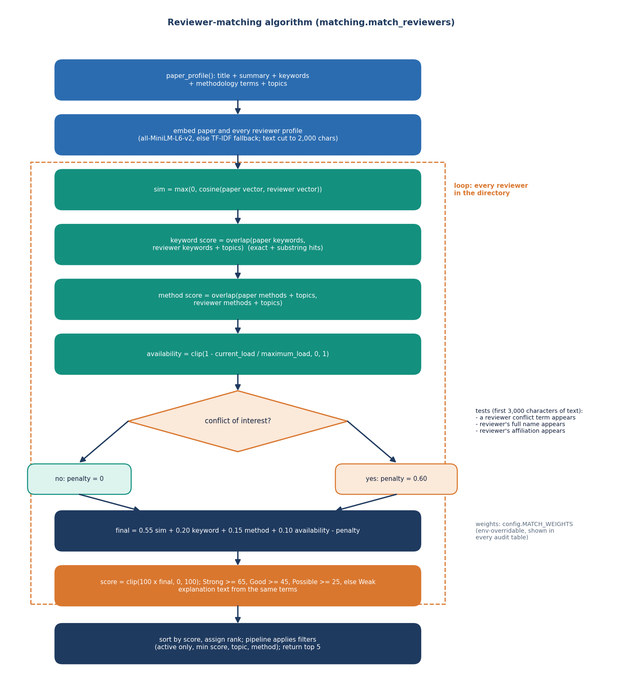
Figure 12: Flowchart of the auditable reviewer-matching algorithm.

1.6.4 Conflict of interest
detect_conflict receives the first 3,000 characters of the paper text and lower-cases them. A reviewer is flagged if any of their conflict terms occurs, if their full display name occurs (a first name alone is not enough), or if their affiliation string, at least five characters long, occurs. The flag carries a reason sentence, and a flagged reviewer has the penalty of 0.60 subtracted before scaling, which in practice moves the reviewer to the bottom of the list. The method is deliberately simple and auditable, and its limit is that it finds only literal strings.

1.6.5 Pipeline filters and storage
After scoring, run_analysis applies the filters the user chose: active reviewers only (the default), a minimum score, and substring filters on topic and method. It keeps the first five and builds the result. main.analyze then stores the row and returns the result. The response also carries a warning if fewer than 50 words were extracted, which happens with scanned PDFs.
Table 10: Configuration read by app/config.py
Setting | Default | Effect
PEERSCOPE_HOST, PEERSCOPE_PORT | 127.0.0.1, 8408 | Where the API listens
PEERSCOPE_MAX_UPLOAD_MB | 20 | Largest accepted PDF
PEERSCOPE_LLM_MODEL, PEERSCOPE_LLM_FALLBACK | Qwen2.5-1.5B-Instruct, Qwen2.5-0.5B-Instruct | Local language models
PEERSCOPE_EMBED_MODEL | all-MiniLM-L6-v2 | Sentence encoder
PEERSCOPE_LITERATURE_COUNT, PEERSCOPE_LITERATURE_TIMEOUT | 6, 8 s | OpenAlex works requested and timeout
PEERSCOPE_W_EXPERTISE, _KEYWORD, _METHOD, _AVAIL, _CONFLICT | 0.55, 0.20, 0.15, 0.10, 0.60 | Matching weights
PEERSCOPE_DB, PEERSCOPE_TMP, PEERSCOPE_HF_CACHE | data/peerscope.db, data/tmp, models/hf_cache | Storage locations

1.7 Scoring Design
The reviewer score is the central design element, so it is written out in full. For a paper p and a reviewer r, with sim the cosine similarity of the embeddings (negative values set to zero), kw and me the keyword and method overlaps, av the availability and pen the conflict penalty:
score(p, r) = 100 x clip( 0.55 sim + 0.2 kw + 0.15 me + 0.1 av - 0.6 pen , 0 , 1 ) (1)
where av = clip(1 - current load / maximum load, 0, 1) and pen is 1 for a flagged reviewer and 0 otherwise. The result is labelled Strong at 65 or more, Good at 45 or more, Possible at 25 or more and Weak below that. The positive weights sum to one, so a score of 100 would need perfect similarity, overlap and availability. Because the weights are read from the environment, an editor can emphasise availability or similarity without changing code. The explanation sentence is built from the same values: it says whether the semantic match is close (similarity of 0.45 or more), partial (0.25 or more) or limited, lists up to four overlapping terms and up to four shared methods or topics, and states whether availability is good (0.5 or more) or limited.
The weights follow the structure of the base paper's affinity construction, which combines text similarity and keyword overlap [1], but the particular numbers were set by the team and were not fitted. Section 5.9 records why the score was kept linear.

1.8 User Interface Design
The interface is a React single-page application with eight routes: the landing page at the root and, under /app, the Dashboard, Analyze, Saved analysis, Reviewers, Model performance, History and About pages. Pages are loaded lazily, an error boundary keeps a failure in one page from blanking the others, and a not-found screen offers a way back. The look is the 'Depth Studio' kit: Sora, Inter and JetBrains Mono type, a dark theme by default with a light theme that follows the operating system until the user chooses, an emerald accent, rounded cards, a fixed 248-pixel sidebar and a 64-pixel top bar. The theme choice is kept in the browser's local storage.
Table 11: Pages of the web application
Page | Route | Content
Landing | / | Hero scene (three.js with a static fallback), how-it-works steps, features, call to action
Dashboard | /app | Counts of reviewers and analyses, decision-model accuracy with a synthetic-data note, recent analyses, how it works, concerns chart
Analyze | /app/analyze | PDF drop zone with size check, filters (active only, minimum score, topic, method), progress with elapsed seconds, five-tab result
Saved analysis | /app/analyses/:id | The same five-tab result for a stored analysis
Reviewers | /app/reviewers | Searchable table with load bars, add and edit form, activate, delete with confirmation, CSV import and export
Model performance | /app/model | Accuracy, macro precision, recall and F1, class distribution, confusion matrix, per-class table, training details
History | /app/history | Sortable, searchable list of analyses with open, JSON and PDF actions
About | /app/about | Pipeline, scoring formula, responsible use, privacy, live system status


Figure 13: Landing page of the web application (dark theme).
The result view is organised so that the most important facts come first. Four summary tiles show the structural score, the number of concerns, the number of recommendations and the top reviewer. The Overview tab shows the paper's metadata and the preliminary assessment, with the historical decision signal, the structural score with its four signals and the status of the local AI review side by side. The Review tab lists strengths, concerns, recommendations, a coverage view, the AI synthesis if present, and the evidence excerpts. The Literature tab is a sortable table of related works. The Reviewers tab shows the ranked reviewers with an expandable audit table. The Audit and export tab gives the formula, the analysis identifier, the status of each component and the export buttons.

Figure 14: Analyze page after an analysis: summary tiles and the Overview tab.
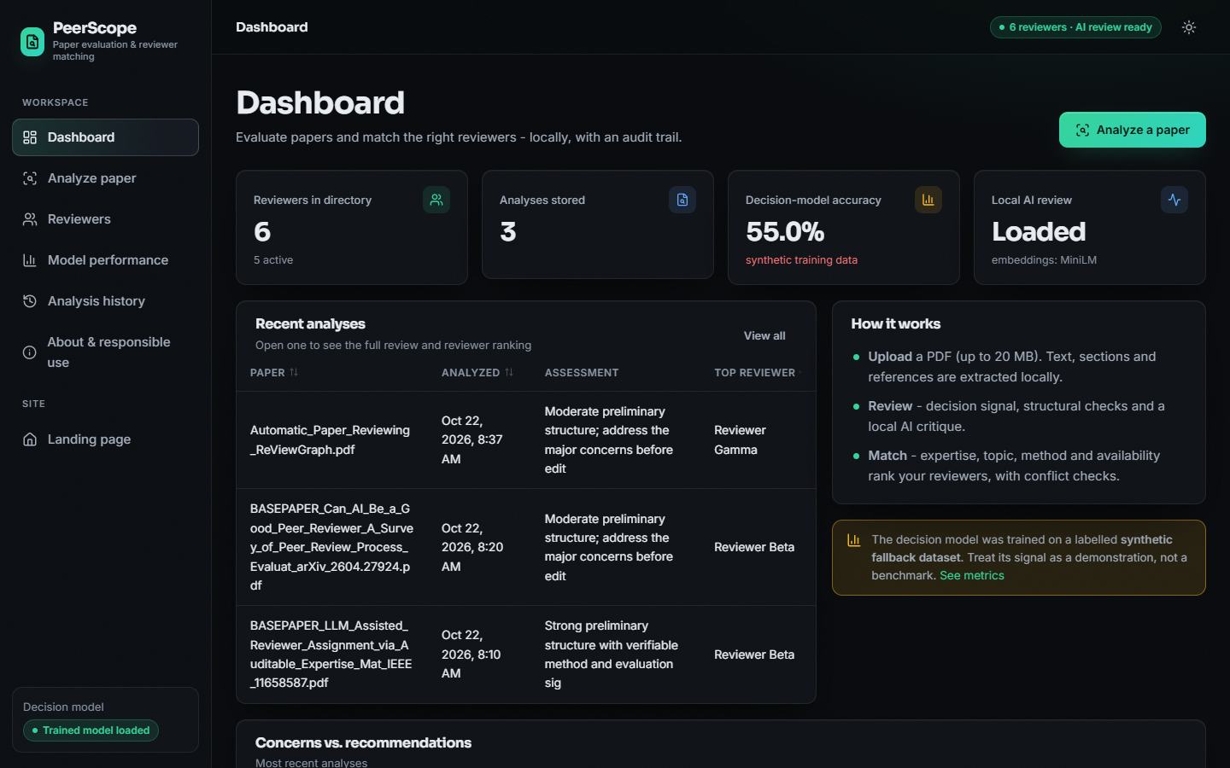
Figure 15: Dashboard with counts, decision-model accuracy and recent analyses.
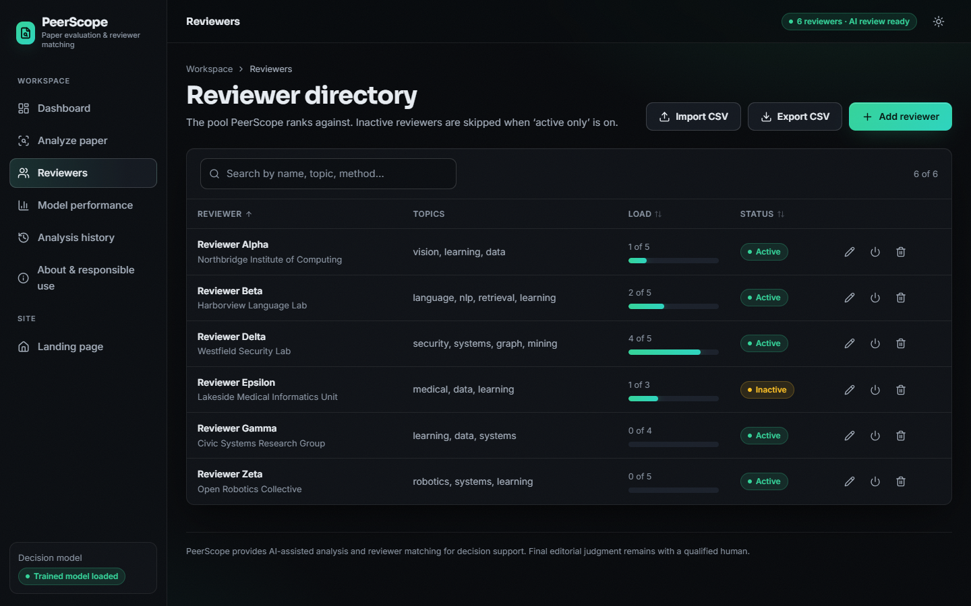
Figure 16: Reviewer directory with load bars, status and actions.
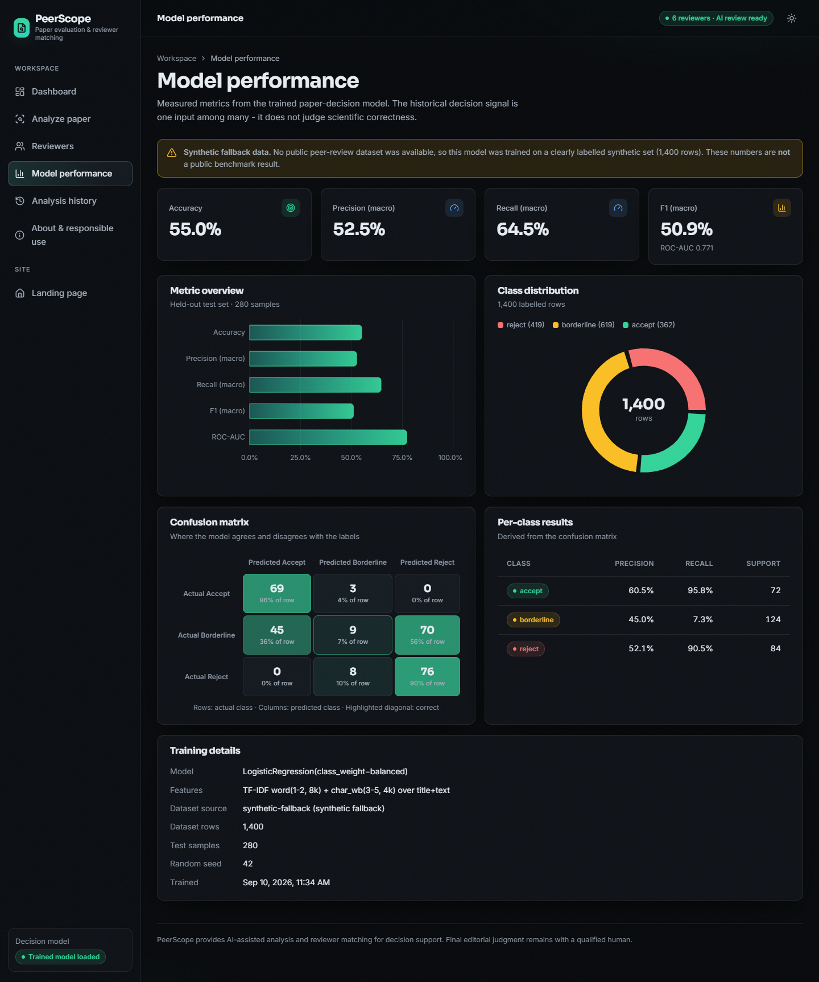
Figure 17: Model performance page with the synthetic-data notice, metrics and confusion matrix.
Four design rules were applied throughout. Honest states: every component that can fail has a visible status, and a banner on the Dashboard and Model pages says that the decision model was trained on synthetic data. Every asynchronous view has loading, empty and error states with a retry. Accessibility: controls are native or labelled, tabs expose their panel, progress bars carry text and the colour tokens keep text legible in both themes. Responsiveness: tables hide secondary columns on narrow screens and the sidebar becomes a slide-in drawer.

1.9 Key Design Decisions
Table 12: Design decisions, alternatives and reasons
Decision | Alternative considered | Reason
Process PDFs locally; send only a title query out | Upload the paper to a hosted language model | Peer review material is confidential, and hosted tools raise the manipulation risks described in the literature [2], [27]
Deterministic review always runs; the language model is optional | Language model only | The system must give a useful, honest result when the model cannot load or the machine is slow
Linear weighted score with explicit availability and conflict terms | A learned ranking model | No labelled assignments were available, and a linear score can be audited line by line, as the base paper recommends [1]
MiniLM embeddings with a TF-IDF fallback | TF-IDF only, or a larger encoder | MiniLM runs quickly on a CPU and is the encoder family used by the base paper's baseline; the fallback keeps the system working offline
TF-IDF and logistic regression for the decision signal | Fine-tuning a transformer | No real decision data, CPU only, and a linear model is fast to train and to explain; its output is a labelled demonstration
Class-balanced weights | Unweighted fit | The borderline class is the largest; balancing raises macro recall at the cost of some accuracy
SQLite with a JSON snapshot per analysis | Normalised tables with foreign keys | Single user, no server, and a stored analysis must not change when the directory changes
Comma-separated lists in text columns | Child tables for topics and methods | Simple CSV import and export; the lists are short and only read by the matcher
Service modules as functions over dictionaries | Class hierarchy | Each stage is testable alone and the result is directly storable as JSON
Weights and limits read from the environment | Constants in code | An editor can tune the ranking without a code change
No authentication | Accounts and roles | Out of scope for a local single-user tool; listed as future work
Top five reviewers returned | Return all | A short list is what an editor needs; the pool size is stored with the result

Two further decisions concern honesty and are visible in the interface. The coverage view in the Review tab uses a fixed value for the Novelty axis, because novelty cannot be measured from the paper alone, and the novelty text says so; and the Model page shows a notice whenever the metrics file says that the data were synthetic. The design therefore errs on the side of showing what the system does not know.

2. IMPLEMENTATION

2.1 Application architecture and implementation
PeerScope is a three-tier local application of about 1,449 lines of Python (app/), 6,926 lines of React code and styles (frontend/src/) and 542 lines of supporting scripts, with 114 lines of tests. The architecture is shown in Chapter 5; the points below describe how it is realised.
API tier. app/main.py creates one FastAPI application, initialises the SQLite schema through SQLAlchemy, seeds the six demo reviewers if the table is empty (a seeding failure is logged and never stops start-up) and declares all routes. The routes are thin: file validation and persistence are in main.py, everything else is delegated to service modules in app/services/ (pdf_extract, features, ml_predict, review_synthesis, llm_service, literature, embeddings, matching, pipeline, export_service, seed). The services are plain function modules without hidden state, except three lazily created singletons: the classifier and vectoriser (loaded on first use), the sentence-embedding model and the language model. Each loader catches its own exceptions and records the error, so a missing package or an offline machine degrades one feature instead of the whole request.
Pipeline module. pipeline.run_analysis is the only place where the stages are composed. It runs them in a fixed order, applies the user's filters to the ranked reviewers (active only, minimum score, topic text, method text), keeps the five best and assembles the result dictionary that is returned to the browser and stored as JSON.
Web tier. The React application (Vite, port 5408) calls the API through a small client (lib/api.js) whose errors carry a message that is safe to show. It has eight views: landing page, dashboard, analysis form and result, reviewer directory, model performance, history, saved analysis and an about page that states responsible use. A result is shown in five tabs (Overview, Review, Literature, Reviewers, Audit and export), and each reviewer card opens a table with the five score components, their values and weights. The original vanilla-JavaScript interface remains in static/ and is served by the API at / as a fallback.
The interface is built from a small component set (layout, navigation, form controls, feedback and display components) with design tokens for dark and light themes, Recharts for the metric and class charts, motion libraries for entrance animation and a three.js scene on the landing page with a static fallback image. Data loading uses a small useAsync hook; the analysis request can be aborted by the user (an AbortController signal is passed to fetch), and when the backend cannot be reached the client throws an error that tells the user to start it with run.bat. The model-performance page reads /api/model/metrics and shows the synthetic-data warning whenever synthetic_fallback is true, so the figures cannot be mistaken for a benchmark.
Storage. Two SQLite tables: reviewers and analyses. The second keeps a summary (file name, time, overall assessment, concern and recommendation counts, top reviewer name) and the complete result as a JSON text column, so a saved analysis can be re-opened and exported without recomputation. There is deliberately no foreign key between them; the ranked reviewers are a snapshot inside the JSON.

2.1.1 Key code: the match score
for r, sim in zip(reviewers, sims):
rp = reviewer_profile(r)
kw_s, kw_hits = _overlap(paper["keywords"], rp["keywords"])
m_s, m_hits = _overlap(paper["methods"] + paper["topics"], rp["methods"] + rp["topics"])
maxload = max(int(r.maximum_load or 5), 1)
avail = max(0.0, min(1.0, 1.0 - (int(r.current_load or 0) / maxload)))
conf = detect_conflict(paper_text_extra, "", r)
penalty = float(w["conflict_penalty"]) if conf["conflicted"] else 0.0
raw = (w["expertise_similarity"] * sim + w["keyword_score"] * kw_s
+ w["method_score"] * m_s + w["availability_score"] * avail - penalty)
score100 = round(max(0.0, min(100.0, raw * 100)), 1)
strength = "Strong" if score100 >= 65 else ("Good" if score100 >= 45 else ("Possible" if score100 >= 25 else "Weak"))

The function is a direct transcription of the formula in Section 6.5.2. Every intermediate value is returned in a breakdown dictionary together with the weights, and an explanation sentence is generated from the same values, so what the interface shows is exactly what was computed.

2.1.2 Key code: the analysis pipeline
doc = pdf_svc.extract_pdf(pdf_path)
feats = feat_svc.extract_features(doc)
ml = ml_svc.predict_decision(doc.get("title", ""), doc.get("paper_summary", ""), doc.get("full_text", ""))
review = rev_svc.llm_review(doc, feats) # deterministic review + optional 3-step local LLM
lit = lit_svc.retrieve_literature(doc.get("title", ""), feats["keywords"], feats["research_topics"])
paper_prof = match_svc.paper_profile(doc["title"], doc["paper_summary"], feats["keywords"],
feats["methodology_terms"], feats["research_topics"])
ranked = match_svc.match_reviewers(paper_prof, reviewers, doc["full_text"][:4000])

Each stage returns plain dictionaries with an explicit status field where it can fail (llm_status, literature_retrieval_status, the decision model's status), and the front end shows those statuses instead of hiding a missing component.

2.2 API design
The API is a JSON-over-HTTP interface on port 8408, documented automatically at /docs by FastAPI. Request bodies are validated by Pydantic schemas; the reviewer schema limits name length (1-200), text fields (2,000-4,000 characters) and loads (0-100, maximum load 1-100).
Table 13: Endpoints
Method and path | Request | Success response | Error responses
GET /api/health | - | Status, product, LLM state (loaded or lazy-not-loaded), embedding backend, model-loaded flag, reviewer count | -
GET /api/model/metrics | - | Contents of models/metrics.json, or status: missing | -
GET /api/reviewers | - | List of reviewers (12 fields) | -
POST /api/reviewers | JSON reviewer; display_name required | 201 and the stored reviewer | 422 invalid field; 400 save failure
PUT /api/reviewers/{id} | JSON reviewer | 200 and the updated reviewer | 404 unknown id; 422; 400
DELETE /api/reviewers/{id} | - | {"deleted": id} | 404 unknown id
GET /api/reviewers/export/csv | - | CSV attachment peerscope_reviewers.csv | -
POST /api/reviewers/import | Multipart CSV file | {"imported": n} | 400 unreadable or malformed CSV
POST /api/analyze | Multipart: file (PDF), active_only, min_score, topic, method | Full analysis result and analysis_id; a warning if fewer than 50 words were extracted | 400 not a PDF, empty, bad header or no reviewers; 413 over 20 MB; 500 analysis failure
GET /api/analyses | - | Stored analyses, newest first | -
GET /api/analyses/{id} | - | Stored result JSON | 404 unknown id; 500 corrupted record
GET /api/analyses/{id}/export | format=json or pdf | Attachment: JSON file or a PDF report built with ReportLab | 404 unknown id

The analysis result contains these top-level fields: paper (title, summary, pages, words, references, detected sections, preview of the first four pages), features, ml_decision_signal (label, confidence, probabilities, note), structural_assessment, review (strengths, major and minor concerns, method, evidence, clarity and reproducibility comments, novelty considerations, recommendations, a six-axis coverage object, evidence references, llm_status and, when available, the AI synthesis), review_quality, literature (status and works), reviewers (the five best, each with score, strength, matching terms, availability, conflict result, breakdown and explanation), the pool size, the disclaimer and the responsible-use statement.
A global exception handler turns any unexpected error into 500 Internal server error without a stack trace, and HTTPException responses keep their detail message, which the web client shows to the user.

2.3 Security and error handling
• Upload validation. The extension must be .pdf; a declared content type must mention pdf or octet; the body must be non-empty, at most 20 MB (configurable) and start with %PDF. The bytes are written to a temporary file that is deleted in a finally block whatever the outcome, and no uploaded paper is kept on disk or sent to a paid service.
• Input limits. Reviewer fields have maximum lengths and numeric ranges (Pydantic); CSV import truncates long names and affiliations, tolerates missing columns and turns any parsing error into a 400 after rolling back the transaction.
• Injection. All database access goes through the SQLAlchemy ORM with bound parameters; the React interface escapes text; the PDF export escapes &, < and > before ReportLab renders it.
• Degrade, do not fail. A missing classifier, embedding model, language model or network connection sets a status field and the interface says so; the pipeline continues with the deterministic parts.
• Privacy. Text extraction, classification, embeddings and the language model run on the local machine. Only the paper's title (or its keywords) is sent to OpenAlex, with an 8-second timeout.
• What is not protected. The API has no authentication and allows every origin because it is meant for one user on one machine; it must not be exposed to a network as it stands. PyMuPDF parses untrusted PDFs in the server process. Text hidden in a PDF could steer the local language model [2]; the mitigation is architectural (the model's text never changes a score and is labelled as AI output) rather than a filter.
The functional and security tests of Chapter 7 exercise these checks.

2.4 Installation and execution
Quick start (Windows). Install Python 3.11 or 3.12 and Node.js 18 or newer and double-click run.bat. The script checks both tools, creates or repairs the virtual environment, installs requirements.txt, prepares the dataset and trains the decision model if the artifacts are missing, creates the demo PDF, installs the frontend packages, and starts the API on port 8408 and the web application on port 5408 in two windows. The first analysis downloads the sentence-embedding model and the Qwen language model (about 3 GB in models/hf_cache) from Hugging Face; if that fails the application keeps working with the deterministic analysis and a TF-IDF fallback embedder.
python -m venv .venv && .venv\Scripts\activate
python -m pip install -r requirements.txt
python scripts/prepare_dataset.py # synthetic corpus (unless a public file is reachable)
python scripts/train_model.py # writes models/decision_model.joblib, tfidf_vectorizer.joblib, metrics.json
python scripts/make_demo_pdf.py # demo paper fixture
python -m uvicorn app.main:app --host 127.0.0.1 --port 8408 # terminal 1
cd frontend && npm install && npm run dev # terminal 2 (http://localhost:5408)
python -m pytest tests # 7 automated tests
python scripts/smoke_test.py # live API checks against the running server
python scripts/capture_screens.py # real screenshots with Playwright

Table 14: Configuration variables (.env, app/config.py)
Variable | Default | Meaning
PEERSCOPE_PORT / FRONTEND_PORT | 8408 / 5408 | API and web ports
PEERSCOPE_MAX_UPLOAD_MB | 20 | Largest accepted PDF
PEERSCOPE_LLM_MODEL / PEERSCOPE_LLM_FALLBACK | Qwen2.5-1.5B-Instruct / 0.5B-Instruct | Local review models (set to an unknown name to switch the AI review off)
PEERSCOPE_EMBED_MODEL | sentence-transformers/all-MiniLM-L6-v2 | Embedding model
PEERSCOPE_LITERATURE_COUNT / _TIMEOUT | 6 / 8 s | OpenAlex results and timeout
PEERSCOPE_W_EXPERTISE, _KEYWORD, _METHOD, _AVAIL, _CONFLICT | 0.55, 0.20, 0.15, 0.10, 0.60 | Matching weights (positive weights sum to 1)
PEERSCOPE_DB | sqlite:///data/peerscope.db | Database URL
VITE_API_URL | http://127.0.0.1:8408 | API address used by the web application

A Dockerfile builds the API image (Python 3.12) and trains the model at build time; the web application is started separately. Configuration is read from .env (host, ports, upload limit, model names, number of literature results, timeout and the five matching weights), and real environment variables take precedence. Appendix B gives the step-by-step user guide.

3. KEY CODE WALK-THROUGHS
This section walks through the code that carries the design. The listings are copied from the repository at the state in which the results were measured.

3.1 From a PDF to sections
SECTION_PATTERNS: dict[str, list[str]] = {
"summary": [r"^\s*summary\s*$", r"^\s*overview\s*$"],
"introduction": [r"^\s*1?\s*introduction\s*$", r"^\s*1\s+introduction"],
"related_work": [r"related work", r"background", r"literature review"],
"methodology": [r"methodology", r"^\s*method\s*$", r"approach", r"model\b", r"architecture"],
"experiments": [r"experiment", r"evaluation\b", r"setup"],
"results": [r"^\s*results?\s*$", r"findings"],
"discussion": [r"discussion"],
"conclusion": [r"conclusion", r"future work", r"concluding"],
"references": [r"^\s*references\s*$", r"^\s*bibliography\s*$"],
}

def _detect_sections(full_text: str) -> dict[str, dict]:
found: dict[str, dict] = {}
lines = full_text.split("\n")
# Candidate headings: short lines (<80 chars).
positions: list[tuple[int, str]] = []
for idx, ln in enumerate(lines):
s = ln.strip()
if not s or len(s) > 80:
continue
low = s.lower().strip("0123456789. ")
for key, pats in SECTION_PATTERNS.items():
if any(re.search(p, low) for p in pats):
if key not in found:
positions.append((idx, key))
break
positions.sort()
for n, (line_idx, key) in enumerate(positions):
end = positions[n + 1][0] if n + 1 < len(positions) else len(lines)
body = "\n".join(lines[line_idx + 1 : end]).strip()
found[key] = {
"heading_line": lines[line_idx].strip(),
"char_count": len(body),
"word_count": len(re.findall(r"[A-Za-z0-9']+", body)),
"preview": body[:600],
}
return found

Every short line (80 characters or fewer) is lower-cased, stripped of digits, dots and spaces at its ends and tested against the pattern lists of the nine section types. The first heading found for a type starts that section, which ends at the next heading; word counts and a 600-character preview are stored. The patterns are deliberately simple, which explains two measured weaknesses: I. INTRODUCTION does not match ^\s*1?\s*introduction\s*$, so the IEEE base paper reports no introduction, and loose patterns such as model or approach can mark an ordinary heading as the methodology.

3.2 Structural score
struct = round(100.0 * len(present) / len(EXPECTED), 1)
evidence = min(100.0, round(ref_density * 22 + (10 if "experiments" in sections or "results" in sections else 0), 1))
method_sig = 100.0 if "methodology" in sections and sections["methodology"].get("word_count", 0) >= 120 else (
70.0 if "methodology" in sections else (45.0 if method_terms else 25.0))
present_sig = 100.0 if 12 <= avg_sent <= 26 and pct_short < 40 else (
75.0 if 8 <= avg_sent <= 32 else 50.0)

overall_struct = round(0.35 * struct + 0.25 * evidence + 0.25 * method_sig + 0.15 * present_sig, 1)

Structure completeness is the share of nine expected sections found. Evidence coverage grows with references per page (22 points each, plus 10 when an experiments or results section exists) and is capped at 100. Method clarity is 100 for a methodology section of at least 120 words, 70 for a shorter one, 45 when only method terms occur and 25 otherwise. Presentation rewards an average sentence length of 12 to 26 words and few very short sections. The four values are combined as 0.35, 0.25, 0.25 and 0.15. None of these constants was fitted to human ratings.

3.3 Decision signal
def predict_decision(title: str, summary: str, full_text: str = "") -> dict[str, Any]:
"""Return the historical-decision signal from the trained classifier."""
model, vec = _lazy_load()
if model is None or vec is None:
return {
"status": "model_unavailable",
"label": "unavailable",
"confidence": 0.0,
"probabilities": {},
"note": "Trained decision model artifacts not found. Run scripts/train_model.py.",
}
blob = f"{title or ''} {summary or ''} {(full_text or '')[:4000]}".strip()
x = vec.transform([blob])

try:
proba = model.predict_proba(x)[0]
classes = list(model.classes_)
best = int(proba.argmax())
names = [idx_to_name.get(int(c), _name(c)) if str(c).isdigit() else str(c) for c in classes]
# When classes_ are 0..n-1, idx_to_name maps position directly.
probs = {str(n): round(float(p), 4) for n, p in zip(names, proba)}
return {
"status": "ok",
"label": str(names[best]),
"confidence": round(float(proba[best]), 4),
"probabilities": probs,
"note": "Historical decision signal learned from prior review records; not a judgment of scientific correctness.",
}
except Exception:
raw = str(model.predict(x)[0])
label = idx_to_name.get(int(raw), raw) if raw.isdigit() else raw
return {"status": "ok", "label": label, "confidence": 0.0,
"probabilities": {label: 1.0}, "note": "Prediction without calibrated probabilities."}

The classifier is loaded lazily from the two joblib artefacts; if either is missing the function returns model_unavailable instead of raising, and the interface shows that state. The input is the title, the summary and the first 4,000 characters of the text, vectorised by the saved word and character TF-IDF pair. Class names come from the metrics file, because the label encoder sorted them alphabetically (accept, borderline, reject). The returned dictionary carries the label, its probability and all three probabilities, together with a note that the signal is historical and not a judgement of correctness.

3.4 Overlap and conflict check
def _overlap(a: list[str], b: list[str]) -> tuple[float, list[str]]:
if not a or not b:
return 0.0, []
sa, sb = set(a), set(b)
hits = sorted(sa & sb)
# partial substring hits
for x in sa:
for y in sb:
if x != y and (x in y or y in x) and x not in hits and y not in hits:
hits.append(f"{x}~{y}")
denom = max(len(sa), len(sb))
return round(min(1.0, len(hits) / denom + 0.1 * len(hits) / max(denom, 1)), 4), hits

def detect_conflict(paper_text: str, paper_title: str, r) -> dict:
low = f"{paper_text[:3000]} {paper_title}".lower()
terms = [t for t in _split(r.conflict_terms) if t]
hits = [t for t in terms if t and t in low]
name_hit = bool(r.display_name and r.display_name.lower().split()[0] in low and len(r.display_name.split()[0]) > 3 and r.display_name.lower() in low)
aff_hit = bool(r.affiliation and len(r.affiliation) > 4 and r.affiliation.lower() in low)
conflicted = bool(hits or name_hit or aff_hit)
reason = ""
if hits:
reason = f"Conflict term match: {', '.join(hits[:3])}."
elif name_hit:
reason = "Reviewer name appears in the paper text."
elif aff_hit:
reason = "Reviewer affiliation appears in the paper text."
return {"conflicted": conflicted, "reason": reason, "terms": hits}

_overlap counts exact shared terms plus substring hits (reported as x~y) and divides by the larger set, so a long profile is not rewarded for length. detect_conflict lower-cases the first 3,000 characters of the paper and looks for the reviewer's conflict terms, the full display name, or the affiliation. Any hit sets conflicted and supplies a reason that the interface prints beside the reviewer. The test is a plain substring test, which is why reworded affiliations and first-name-only mentions are not found. The weighted loop that turns these values into the 0-100 score is listed in Chapter 6.

3.5 Local language-model review with a visible fall-back
def llm_review(doc: dict, feats: dict) -> dict[str, Any]:
"""Run the 3-step local LLM pipeline; fall back to deterministic review with visible status."""
from app.services import llm_service

base = deterministic_review(doc, feats)
if llm_service.ensure_llm() is None:
base["llm_status"] = "unavailable"
base["llm_note"] = ("Local AI model unavailable in this environment "
f"({(llm_service.llm_status().get('error') or 'not downloaded')}). "
"Showing deterministic structural review only.")
return base
excerpt = (doc.get("full_text", "") or "")[:6000]
a = llm_service.generate(f"{ANALYZE_SYS}\nPAPER TITLE: {doc.get('title')}\nEXCERPT:\n{excerpt}\n\nList: problem, contribution, approach, setup, claims, evidence, strengths, weaknesses, missing info.", 512)
b = llm_service.generate(f"{CRITIQUE_SYS}\nPAPER TITLE: {doc.get('title')}\nEXCERPT:\n{excerpt}\n\nCritique method clarity, evidence, completeness, reproducibility, limitations, consistency.", 512)
c = llm_service.generate(f"{SYNTH_SYS}\nPAPER TITLE: {doc.get('title')}\nANALYSIS:\n{a.get('text','')}\nCRITIQUE:\n{b.get('text','')}\n\nProduce the structured assessment now.", 700)
if c.get("status") != "ok" or not c.get("text"):
base["llm_status"] = "error"
base["llm_note"] = f"AI generation failed ({c.get('error', 'empty output')}); showing deterministic review."
return base
base["llm_status"] = "ok"
base["llm_model"] = c.get("model")
base["ai_synthesis"] = c["text"]
base["ai_analysis_step"] = a.get("text", "")[:2000]
base["ai_critique_step"] = b.get("text", "")[:2000]
base["source"] = "deterministic+llm"
return base

The deterministic review is always built first, so a result exists whatever happens next. If the model cannot be loaded, the function records llm_status = unavailable with the reason and returns the deterministic review. Otherwise three prompts are run on the first 6,000 characters: analyse, critique and synthesise. If the final generation fails or is empty the status becomes error and the deterministic review is kept. On success the three texts, the model name and source = deterministic+llm are added. The three generations produce about 1,400 tokens and account for almost all of the time of an analysis.

3.6 Validation at the analysis endpoint
fname = file.filename or "upload.pdf"
if not fname.lower().endswith(".pdf"):
raise HTTPException(400, "Only PDF files are accepted (.pdf).")
if file.content_type and "pdf" not in file.content_type.lower() and "octet" not in file.content_type.lower():
raise HTTPException(400, f"Unexpected file type: {file.content_type}. Please upload a PDF.")
data = await file.read()
if not data:
raise HTTPException(400, "Uploaded file is empty.")
if len(data) > MAX_UPLOAD_BYTES:
raise HTTPException(413, f"File too large ({len(data)/1048576:.1f} MB). Limit is {MAX_UPLOAD_BYTES/1048576:.0f} MB.")
if not data.startswith(b"%PDF"):
raise HTTPException(400, "File does not look like a valid PDF (missing PDF header).")

try:
result = pipe.run_analysis(tmp.name, fname, reviewers,
{"active_only": active_only.lower() == "true",
"min_score": float(min_score or 0), "topic": topic, "method": method})
except ValueError as exc:
raise HTTPException(400, str(exc))
except Exception as exc:
log.exception("analysis failed")
raise HTTPException(500, "Paper analysis failed. Try another PDF.")

The file name must end in .pdf, the declared content type must mention pdf or be an octet stream, the body must not be empty, must not exceed the configured limit (413) and must begin with %PDF. A directory without reviewers is refused (400). A ValueError from the pipeline becomes a 400 with its message; any other exception is logged and returned as a generic 500, so internal details do not reach the client. The temporary file is removed in a finally block.

4. IMPLEMENTATION DECISIONS AND THEIR REASONS
Each decision below is stated with the alternative that was available and the reason for the choice.
Table 15: Implementation decisions
Decision | Alternative | Reason
Process papers locally; send only title and keywords to OpenAlex | Cloud language-model API | Manuscripts are confidential; no key, no cost, no data leaves the machine; the price is speed and quality
Always build the deterministic review, add the LLM when available | Fail the request without the model | A useful result exists on any machine; the interface shows which components ran
Visible status for every optional part (LLM, literature, decision model) | Silent fall-back | Nothing is fabricated and the editor knows what to trust
TF-IDF word and character features with logistic regression | Fine-tuned transformer classifier | Small, fast, inspectable; with synthetic labels a larger model could not add real signal (accuracy 0.55 against a ceiling near 0.56)
class_weight=balanced | Unweighted training | Gives minority classes weight; macro recall rises to 0.65 from 0.56 while accuracy changes little
all-MiniLM-L6-v2 cosine as the expertise term | Larger or domain-specific encoder (SPECTER) | Small enough for a CPU, the same family as the base paper's baseline; semantic-only ranking reached top-1 97.5% on the probe set
Weights 0.55, 0.20, 0.15, 0.10 and a 0.60 penalty | Learned weights | No real labels to fit them; documented, configurable by environment variable and shown in every breakdown; semantic-only scored a little higher on the probe set, so the lexical terms mainly serve explanation
Availability as 1 - load / maximum load | Hard capacity filter | Keeps a loaded but expert reviewer visible with a lower score; an inactive reviewer can be filtered
Conflict as a score penalty, not removal | Exclude conflicted reviewers | The editor can see who was penalised and why, and decide
Two SQLite tables, result stored as a JSON text column, no foreign key | Normalised schema | A saved analysis re-opens and exports exactly as computed; ranked reviewers are a snapshot that must not change if a profile is edited later
No login or roles | Authentication | Single-user local tool; adding it was outside the time available and is listed as future work
Load the language model on first use, with a fall-back size | Load at start-up | Start-up stays fast; memory is only used when a review is requested
Report the synthetic nature of the decision data in the interface | Show the metrics alone | The 55 % accuracy cannot be mistaken for a benchmark result

